**Systems of Equations**

**6x + 3y** = **9**

**2y - 2x** = **12**

What is the solution to this system of equations?

To see what’s going on here a little bit better, it might help to rearrange the equations.

Both equations involve x and y, so we could **6x + 3y** = **9**

make them into linear equations. We just need

to get y alone on the left side. 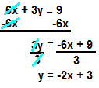

We subtract **6x** from both sides.

Then we divide both sides by **3** to get y alone.

This gives us the line...

We can do the same thing to the second equation. **2y - 2x** = **12**

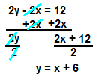

We start by adding **2x** to both sides.

Then we divide **2** from both sides to get y alone.

This gives us the line.

NEW PAGE

We can graph these two lines. 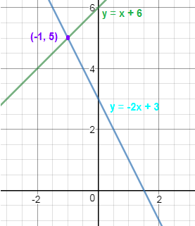

The point where the two lines **intersect**

is the **solution** to the system. Both

equations are in the exact same place

at **(-1, 5)**, meaning that they are both

momentarily **equal**.

When we’re calculating the solution to

a system of equations, we’re looking

for the point (or, sometimes, the points)

where the two equations intersect, the

places where the two equations are

exactly equal.

NEW PAGE

We don’t have to graph the equations to find the intersections. If a systems of equations question shows up on the non-calculator part of the test, we won’t be able to. We can use algebra to see where the two equations intersect.

The equations intersect when they’re exactly **y** = **-2x + 3**

equal to each other. We’ll start, then, by setting **y** = **x + 6**

the equations equal to each other.

**-2x + 3** = **x + 6**

We solve for x by getting x alone on one side of 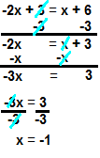

the equation.

We subtract **3** from both sides.

Then, we subtract **x** from both sides so that all of

our **x** values are on the left.

This leaves us with…

We’ll divide both sides by **-3** to get **x** alone.

Now that we have x, we can plug that back into **y** = **x + 6**

one of the original equations to find y. **y** = **-1 + 6**

**y** = **5**

Finally, we can put our answers into one ordered pair. **(-1, 5)**

NEW PAGE

**Substitution and Elimination**

We don’t always have to take the equations about this much. We can frequently bypass all of this work with substitution or elimination.

Systems of equations questions will generally give us two variables. We can’t solve for both at once. Substitution and elimination are ways of isolating one variable at a time.

**Substitution**

Let’s say we’re tasked with solving this system: **2A + 6B** = **26**

**2A + 3B** = **14**



Notice that we have **2A** in both equations. Thus,

if we find out what **2A** itself equals in one of the

equations, we can plug that value back into the

other one.

Now that we know that **2A** equals **14 -3B**, we 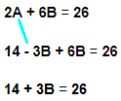

can plug **14 - 3B** back into the first equation in place

of **2A.**

Combining our **B**s, we get…

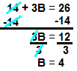

We solve for **B** by getting it alone on the left side.

First, we’ll subtract **14** from both sides.

We’ll get **B** all alone by dividing both sides

by **3**.

Now that we know that **B** = **4**, we’ll plug that back **2A + 3B** = **14**

into one of the original equations to find **A**. **2A + 3(4)** = **14**

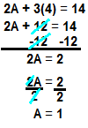

Again, we solve for **A** by getting it alone on one

side of the equation.

We start by subtracting **12** from both sides.

Now, we get **A** alone by dividing both sides by **2**.

NEW PAGE

**Elimination**

We could also solve this system with elimination. **2A + 6B** = **26**

Elimination is based on the idea that we can add  **2A + 3B** = **14**

an entire equation to another one or subtract an entire

equation from another one.

Since both of these equations involve **2A**, then

those **2A**s will cancel each other out if we subtract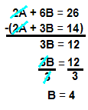

the second equation from the first.

We can only combine like terms (**A**s with **A**s, **B**s with **B**s,

and integers with other integers).

We end with the same solution.



Again, we would plug **4** in for **B** in one of the

original equations to find **A**.

NEW PAGE

We need the coefficients to line up before we can use substitution or elimination. If the numbers in front of the variables don’t match in the two equations, we’ll have to play around with one or both of them.

What if we’re asked to solve for **B** in this system? **9A + 10B** = **7**

**3A + 3B** = **2**

We can’t do substitution or elimination yet

because the numbers in front of our **A**s and **B**s

aren’t the same. However, since **3** goes into **9**, we

can align these coefficients by multiplying the entire

second equation by **3**.

We want to be sure to multiply each term in the

equation by **3**. Our new equation would be… **9A + 9B** = **6**

Our system looks like… **9A + 10B** = **7**

**9A + 9B** = **6**

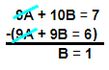

We can now subtract the second equation from

the first one now.

NEW PAGE  
  
Occasionally, the test will have us solve a system involving a non-linear equation. These are very similar to systems involving linear equations. Our solutions will still be at the points where the equations cross paths, the points on the graph where the equations are equal.

Let’s say we’re asked to solve this system: **y** = **2**

**y** = **x2 + 5x + 6**

This looks different than the systems we’ve

been working with, but the solutions will

still be at the intercepts, the places where the

equations equal each other. Hence, we can

find the solutions by setting the equations equal to

each other. This is convenient because they both

start out equal to y. **2** = **x2 + 5x + 6**



The solutions to a quadratic equation like this

are found at the **zeros**, the values for **x** that

make the whole function equal zero.

Now, we’ll **factor** the right side to get our 0s.

We’re looking for integers that add up to 5

and multiply out to 4. Hence… **0** = **(x + 4)(x + 1)**

We flip the values of those integers to get the

solutions, so our x values are… **x** = **-1 and -4**

From the **y** = **2** equation, we know that the

y values are both **2**.

NEW PAGE

This is borne out when we graph the system.

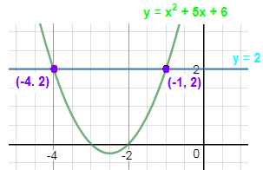

NEW PAGE

**Multiple Choice**

**2a + b** = **4**

**a - b** = **11**

What is the solution to the system of equations written as **(a, b)**?

A) (2, 0)

B) (13, 2)

C) (3, -2)  
D) (5, -6)

**Tell me why:**

We can’t solve for both variables at once, but **2a + b** = **4**

we can focus down to one variable at a time **a - b** = **11**

using elimination.

Adding the entire second equation to the first 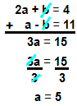

equation cancels out the **b** values.

Now, our task is just to get **a** alone on the left.

To get rid of a coefficient, we divide both sides

by that number

Now that we have **a**, we can plug that back in

to one of the original equations to find **b**. **2(5) + b** = **4**

**10 + b** = **4**



Putting these results back together into **(a, b)**

form, we end up with **(5, -6)**.

With questions like this, students sometimes try to shortcut the question by avoiding the algebra and just plugging the answer choices into the original equation and seeing if they satisfy the equations. This is fine— although it might be just as time-consuming for this particular question— but it’s essential to check each answer in both equations. Each of the wrong answers would satisfy one equation or the other, but they don’t work for both.

If we just plug-and-chug with answer A...

(2, 0) works for the first equation: **2a + b** = **4**

**2(2) + (0)** = **4**

**4** = **4**

However, it doesn’t work for the second one. **a - b** = **11**

**2 - 0** = **11**



NEW PAGE

**Multiple Choice**

**3y - 3x** = **6**

**2y - 4x** = **-2**

If (x, y) is the solution to the system of equations, what is x + y?

A) 3

B) 4

C) 5

D) 8

**Tell me why:**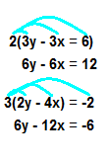

In order to use elimination, we need the coefficients

for one of the variables to line up. Here, both 3

and 2 (the numbers attached to **y**) go into 6.

That means that we can get a pair of aligned

coefficients by multiplying the first equation by 2

and multiplying the second one by 3.

We can use the elimination method on our

new equations because we have **6y** in both. **6y - 6x** = **12**

**6y - 12x** = **-6**

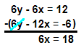

Remember that when we subtract by a negative,

it’s like we’re adding the positive version of that

term.



We get x alone by dividing both sides by **6**.

Now that we have x, we can plug that back

into one of the original equations to find y. **6y - 6x** = **12**

**6y - 6(3)** = **12**

**6y - 18** = **12**

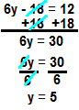

We add **18** to both sides.

We divide both sides by **6** to get y alone.

Remember that the actual final task was to **x + y** = **3 + 5** = **8**

find x + y.

The test writers love to throw in these little side tasks at the end of questions. Be very mindful about what the question is actually asking us for.

**Zero Solutions**

We might have **zero solutions** to a system of equations if the two lines are perfectly **parallel**. If two lines have the same slope (but different y-intercepts), then they never cross paths. Hence, they don’t have any solutions.

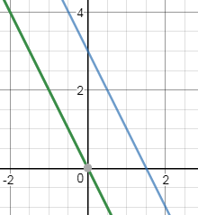

NEW PAGE  
  
**2y - 6x** = **6**

**3y - ax** = **-3**

What is the value of a that would leave this system of equations with zero solutions?

We’ll have zero solutions once we make the

equations parallel. To be parallel, they need

to have the same slope.

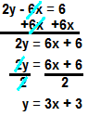

First, we rearrange the first equation to find

out the slope for the already-completed

equation.

The slope for the first equation (the number

attached to the **x**) is 3. That means that we’ll **3y - ax** = **-3**

have to adjust **a** so that the slope of the

second equation becomes 3 also. 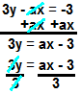

This means that y equals… 

We’re trying to get the slope to equal 3.

Currently, the slope is **a/3**. We can find **a** 

by setting this slope equal to 3.

Finally, we can get **a** alone by multiplying both 

sides by 3.

NEW PAGE

**Infinitely Many Solutions**

Occasionally, we’ll be tasked with creating systems that have **infinitely many solutions**. A system will have infinitely many solutions if the two equations are the exact same. A solution is a place where the two equations hit each other, so two lines that are the exact same will share every single point on the graph.

**4y + cx** = **12**

**8y + 16x** = **24**

What is the value of **c** that would make this system have infinitely many solutions?

To get infinitely many solutions, we’ll need

both lines to be exactly the same: they’ll

have the same slope and the same

y-intercept.

Since we’re already given everything we need **8y + 16x** = **24**

in the second equation, we can solve that back

out into **y** = **mx + b** form. 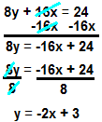

To get back into **y** = **mx + b** form, we need to get

**y** alone on the left side of the equation. To get rid

of the **8** that is multiplying with **y**, we’ll do the

opposite function: divide both sides by **8**.

We set **c** such that the first equation we were given

turns into the exact same thing as **y** = **-2 + 3**.

We’ll start much the same way: we get **y** alone. **4y + cx** = **12**

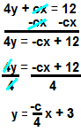

In order to get rid of the **4** that’s multiplying with

**y**, we’ll divide both sides by **4**.

Our two equations already have the same

y-intercept, so we just need to get them the same

slope. Hence, we’ll set the numbers attached to 

**x** equal to each other.

Originally, we’re dividing **-c** by **4**, so we can get rid

of the **4** by multiplying it to both sides. 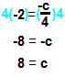

When both sides of an equation are negative, the

negative cancel each other out. This leaves us with...

NEW PAGE

**y** = **8x + 1**

This line shares intersections with all of the following options EXCEPT:

A) y = 4x + 1

B) y = -8x - 1

C) y = 8x + 1.5

D) y = (-1/8)x -5

**Tell me why:**

This line doesn’t share any intersections with **y** = **8x + 1** because the two lines are parallel: they have exactly the same slope. They travel in the same direction forever, never getting any further apart or closer to each other. We can see this when we graph the two.

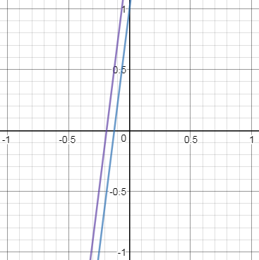

If these two lines we put into a system of equations, there would be zero solutions.

NEW PAGE

**Multiple Choice**

Upfish’s parents reward him for doing well in school by giving him $5 for every A he gets, but they punish him for getting Bs by charging him $3 for every B he gets. Upfish took seven classes last semester and earned $19. How many As did Upfish get? Assume that Upfish only gets As and Bs— you don’t want to know what happens to Upfish gets a C or worse.

A) 1

B) 3

C) 5

D) 7

**Tell me why:**

Let’s use **A** for the number of As that Upfish got

and **B** for the number of Bs. We can summarize

the info in the first two sentences as… **5A - 3B** = **19**

**A + B** = **7**

As with any system of equations, we narrow the

system down to one equation with substitution or

elimination.



This system lends itself well to substitution. We

can get **B** alone in the second equation.

Now that we have **B** alone, we can plug **7 - A**

back into the first equation in place of **B**. **5A - 3B** = **19**

**5A - 3(7 - A)** = **19**



We want to be sure to distribute the **-3** to both

terms inside of the parenthesis. **5A - 21 + 3A** = **19**

Combining our **A**s on the left, we get… **8A - 21** = **19**

We solve for **A** by getting it alone on the left 

side of the equation.



Upfish got five As. Good work, Upfish!

NEW PAGE

**Review**

A system of equations will have a solution where the two equations equal each other. Another way of saying this is that the solutions occur at points where the equations intersect.

We can’t solve for both equations in a system at the same time. Thus, we’ll have to isolate one of the variables at a time. We can use substitution or elimination to focus on one variable at a time.

A system will have infinitely many solutions if the two equations form the same exact line. A system will have zero solutions because the two equations are parallel— this means they’d never cross. Parallel lines have the same slope but different y-intercepts.